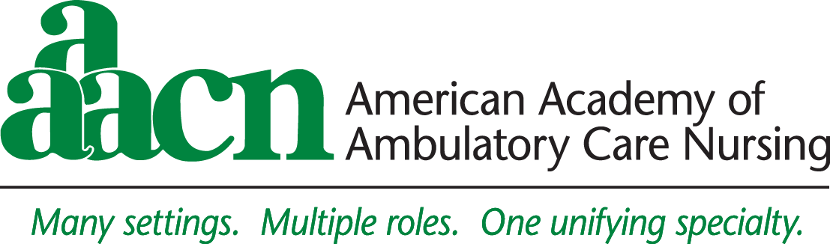

Exhibit Confirmation Notice
45th Annual conference
April 15-18, 2020
Hilton Chicago / Chicago, IL

Dear Exhibitor:

Thank you for submitting your application for exhibit space for AAACN’s 45th Annual Conference to be held April 15-18, 2020. We look forward to working with you on a successful conference. Exhibits will be open on April 15-17.

Exhibit Information
Please note the following information relating to your exhibit.

Any unpaid balances are due immediately. If you should need an invoice for your booth balance, please contact Heidi Perret at heidi.perret@ajj.com

Hotel Reservations - You are responsible for making your own hotel reservations. Hotel rooms are reserved on a first-come, first-served basis. Exhibitors should plan to make arrangements as early as possible. The cutoff date for reservations is March 16, 2020. Make online hotel reservations directly on the AAACN website: www.aaacn.org, or phone the hotel directly at 312-922-4400 and refer to the AAACN Annual Conference. Room rates are $199 single/double per night, plus tax. Online reservations are preferred.

Advance registration for booth personnel. As part of your commercial booth fees, you are entitled to three (3) complimentary booth registrations per 10' x 10' booth. If additional badges are needed, please complete the AAACN Additional Booth Badge Form under Documents/Links on the floorplan page by clicking here and return to heidi.perret@ajj.com. no later than March 27, 2020. All additional badges must be prepaid and can be purchased for $50 each.

Floor plan – To find your booth location, you can view the floorplan by clicking here. Exhibits will be located in Salon D.

AAACN Program at a Glance - Can be found online at: www.aaacn.org

Attendee Registration Mailing List - The cost of the pre-registration list is $500 and is for one-time use only, (the list does not include email addresses or phone numbers). All requests must be prepaid. The request form can be found under Documents/Links on the floorplan page by clicking here. All exhibiting companies will receive a pre-registration list of attendees on-site.

AAACN Program Book Advertising – Let the AAACN attendee know you will be there, by running an ad in the onsite program book handed out to all attendees. A space reservation form can be found under Documents/Links on the floorplan page by clicking here. All ads must be prepaid.

AAACN Opening Reception of Exhibit Hall / Silent Auction – Wednesday April 15, 5:30 pm – 7:30 pm
All exhibiting companies are invited to submit an item for auction and will be recognized with a “Donated by company name and booth number, Stop by and see us !!” Proceeds from the Silent Auction support the AAACN Scholarship and Education Fund. If you wish to participate with an item for auction, please complete the form found under Documents/Links on the floorplan page by clicking here.

AAACN Networking Box Lunch – Thursday April 16, 11:30 am – 12:45 pm
Taking place in the Exhibit Hall – exhibits will be open!!

AAACN National Office: • East Holly Avenue • Box 56 • Pitman, NJ 08071
856-256-2300 • FAX 856-589-7463 • E-mail: aaacn@ajj.com • website: www.aaacn.org
2020 Confirmation Letter

Exhibit services contractor
SourceOne Events has been selected to serve as the official service/drayage contractor. The service kit will be e-mailed to your attention shortly (make sure to check your SPAM folder). All questions regarding shipping and labor should be directed to SourceOne Events. Any questions regarding your booth needs please contact the SourceOne Events customer service directly at phone 708-344-3111 or via email at jessica@sourceoneevents.com. Please note advance shipping/drayage address, plan to have your shipment arrive no later than April 13, 2020.
Exhibiting company name, booth #
AAACN 45th Annual Conference
c/o SourceOne Events, Inc.
160 Eisenhower Lane N.
Lombard, IL 60148

Booth Construction (10’x10’)

Exhibit Schedule

Wednesday, April 15 Exhibitor Set-up 12:00 pm - 5:30 pm All Exhibitors Set-Up
Exhibits Open 5:30 pm - 7:30 pm Opening Reception/Exhibits

Thursday, April 16 Exhibits Open 9:15 am - 10:30 am Refreshment Break
Exhibits Open 11:30 am - 12:45 pm Networking Boxed Lunch
Exhibits Open 3:15 pm - 4:15 pm Dessert Break

Friday, April 17 Exhibits Open 9:30 am - 10:45 am Refreshment Break

Exhibit Dismantling 10:45 am - 2:00 pm

AAACN will provide all exhibitors with pipe and drape, an identification sign, a 6' draped table and two (2) chairs. Exhibit spaces do not include electricity.

Security
AAACN will have a security guard to check badges upon entering the hall. Exhibitors must make arrangements to safeguard valuable property. AAACN is not responsible for any losses incurred by exhibitors.

AAACN Exhibitor Policies
Admission to the exhibit area is by badge only. Exhibitors will be permitted into the exhibit hall 45 minutes prior to opening and must be out of the hall within 30 minutes of closing each day. There will be no exceptions to this policy. Sales meetings and client meetings will not be permitted within the exhibit hall beyond the times outlined above.

As outlined within the exhibitor prospectus, AAACN has numerous policies regarding its exhibit hall. It is impractical to reiterate all rules and regulations here, but exhibitors are reminded to review these policies once again. All exhibitors are expected to adhere to all rules, regulations, and policies governing AAACN’s Conference.

We look forward to working with you in making AAACN's 45th Annual Conference a successful event! Please contact us if we may provide additional information. Thank you.

Sincerely,

Tom Greene
Director of Marketing
856.256.2367
tom.greene@aaacn.org
AAACN National Office: • East Holly Avenue • Box 56 • Pitman, NJ 08071
856-256-2300 • FAX 856-589-7463 • E-mail: aaacn@ajj.com • website: www.aaacn.org

